FAB MICHAELMAS TEST – PAPER 1 (ANSWERS)

- Write short notes on:
  - Carpal tunnel
Under flexor retinaculum (pisiform and hook of hamate scaphoid and trapezium). Floor is made up of other carpal bones. Contains FPL, FDS and FDP tendons and median nerve. If contents swell can cause compression on nerve and ultimately loss of LOAF muscles (sensation over thenar eminence is preserved) = carpal tunnel syndrome.
  - Lower limb arteries
Femoral from external iliac, passes beneath inguinal ligament, between nerve and vein in the femoral triangle. Gives off profunda femoral artery before descending as the SFA to run through adductor canal and eventually adductor hiatus to enter posterior compartment where it becomes the popliteal artery (which subsequently divides into anterior tibial, fibular and posterior tibial). The posterior tibial artery descends in the deep posterior compartment before passing posterior to the medial malleolus where it is palpable. The anterior tibial artery descends on the interosseous membrane in the anterior compartment before passes superficial to become palpable as the dorsalis pedis pulse between the tendons of extensor hallucis longus (medially) and extensor digitorum tendon (laterally).
The femoral artery can form aneurysms or become thrombosed, it is also the site of access for angiograms.
  - Gluteal muscles
Three: gluteal maximus, medius and minimus.
Gluteal maximus is supplied by the inferior gluteal nerve. It arises as deep and superficial fibres. The superficial fibres arise from the PSIS, iliac crest and sacrum. The deep fibres arise from the fascia of gluteus medius and the ilium above the posterior gluteal line and the sacrotuberous ligament. It inserts into the gluteal tuberosity and iliotibial tract. As a result in both adducts and abducts the hip but is an important hip extensor and lateral rotator.
Gluteus medius is supplied by the superior gluteal nerve. It arises from the ilium between the anterior and posterior gluteal lines and inserts into the greater trochanter. It is an important abductor of the hip but because of its anterior and posterior fibres it can medially rotate and flex the hip or laterally rotate and extend.
Gluteus minimus is supplied by the superior gluteal nerve. It arises from the ilium between the anterior and inferior gluteal lines and inserts into the greater trochanter. It abducts and medially rotates the hip.
  - Iliotibial tract
Thickened lateral margin of the fascia lata. Inserting into it are both tensor fascia latae and gluteus maximus. It inserts into the lateral condyle of the tibia.

- Draw a simple diagram of:
  - Cubital fossa 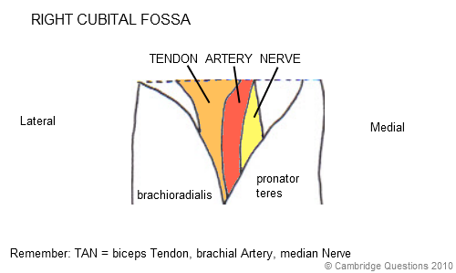
  - Peripheral nerve supply to foot
  - Femoral triangle 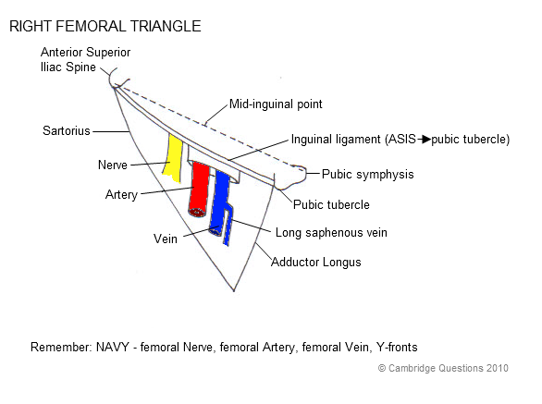
  - Lower limb dermatomes
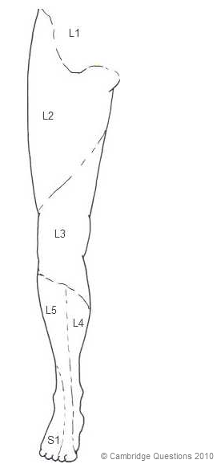
- List:
  - Behind medial malleolus: (Tom, Dick And Very Naughty Harry)
    - Tibialis posterior,
    - flexor Digitorum longus,
    - posterior tibial Artery, Vein, tibial Nerve
    - flexor Hallucis longus
  - Rotator cuff muscles
    - Supraspinatus greater tubercle (superior). Suprascapular nerve
    - Infraspinatus greater tubercle (mid). Suprascapular nerve
    - Teres minor greater tubercle (inferior). Axillary nerve
    - Subscapularis lesser tubercle Subscapular nerve
  - Common extensor origin
    - Extensor carpi radialis brevis base of 3rd metacarpal
    - Extensor digitorum extensor expansions
    - Extensor digiti minimi extensor expansions
    - Extensor carpi ulnaris base of 5th metacarpal
  - Nerve roots of reflexes
    - Ankle S1,2
    - Knee L3,4
    - Biceps C5,6
    - Triceps C7,8
- Compartments (muscles, nerves, actions)
  - Anterior forearm (median nerve, except FCU + ½ FDP)
    - Superficial (flex elbow)
      - Pronator teres pronates
      - Flexor carpi radialis flex wrist, radial deviates
      - Palmaris longus tightens grip
      - Flexor carpi ulnaris flex wrist, ulnar deviates
    - Intermediate
      - Flexor digitorum superficialis flex digits but not DIP joint
    - Deep
      - Flexor digitorum profundus flex digits including DIP joint
      - Pronator quadratus pronates
      - Flexor pollicis longus flex thumb at IP joint
  - Lateral leg (superifical peroneal nerve)
    - Fibularis longus plantar flexes and everts
    - Fibularis brevis plantar flexes and everts
  - Posterior thigh (Tibial branch of sciatic except short head of biceps which is common peroneal nerve)
    - Semimembranosus extend hip, flex knee
    - Semitendinosus extend hip, flex knee
    - Biceps femoris extend hip, flex knee
  - Anterior arm (musculocutaneous nerve)
    - Biceps brachii supinates + flexes
    - Coracobrachialis adducts shoulder
    - Brachialis flexes
- Describe course of:
  - Cephalic vein
Forms at lateral side of dorsal venous arch, crosses anatomical snuff box, ascends superficially to the cubital fossa (over bicipital aponeurosis) where it joins tributary of median cubital vein. Continues to ascend superficially, passing through the deltopectoral groove then piercing the clavipectoral fascia to join the brachial vein.
  - Radial nerve
Forms from the C5-T1 nerve roots of the brachial plexus, posterior cord terminal branch. Descends posteriorly in the spiral groove of the humerus passing from posterior to anterior through the lateral intermuscular septum to lie between brachialis and brachioradialis in the anterior compartment (passes anterior to the lateral epicondyle), descends laterally branching to the deep branch which runs between the two heads of supinator and becomes the posterior interosseous nerve before giving of final sensory branches that can be felt crossing tendon of extensor pollicis longus.
  - Musculocutaneous nerve
Forms from C5,6,7 nerve roots of the brachial plexus and lateral cord. Lies lateral to brachial artery, pierces coracobrachialis, descends between biceps and brachialis, terminates as lateral cutaneous nerve of the forearm.
  - Sciatic nerve
Forms from L4,5, S1,2,3 nerve roots and passes through the greater sciatic notch, deep to piriformis but superficial to the other short lateral rotators. Can split early into the tibial (which later gives sural nerve) and the common peroneal nerves which generally separate at the level of the popliteal fossa.

